

The gaming app

# **CS 230 Project Software Design Template**

Version 1.0

## Table of Contents

**CS 230 Project Software Design Template**1

**Table of Contents**2

**Document Revision History**2

**Executive Summary**3

**Design Constraints**3

**System Architecture View**3

**Domain Model**3

**Evaluation**3

**Recommendations**5

## Document Revision History

| Version | Date | Author | Comments |
| --- | --- | --- | --- |
| 1.0 | 3/21/2021 | Mary Reamer | Develop a game app that displays images as clues so a team can guess a phrase, title or thing. The game must have one or more teams with multiple players. The game and team names must be unique and check if a team name is already in use. Only one instance of the game can exist in memory by having a unique identifier for each. |

**Instructions**

Fill in all bracketed information on page one (the cover page), in the Document Revision History table, and below each header. Under each header, remove the bracketed prompt and write your own paragraph response covering the indicated information.

## Executive Summary

Creative Technology Solutions (CTS) as a technology consultant will develop a web-based game for the client The Gaming room that works on multiple platforms. The game will be based on their current game Draw it or Lose it which is currently an android app. The application will show images from a library of stock drawings and teams will have to guess the phrase title or thing. The game will have four rounds of play lasting one minute each. The images will be shown for 30 seconds if the team does not guess the puzzle before the time expires the other teams have a chance to guess with a 15 second time limit.

## Design Constraints

The web based game should work on multiple platforms window and mac and work on a variety of screen sizes. The framerate on a browser and memory usage are also limiting factors. The budget and time constraints can also be a limiting factor.

## System Architecture View

Please note: There is nothing required here for these projects, but this section serves as a reminder that describing the system and subsystem architecture present in the application, including physical components or tiers, may be required for other projects. A logical topology of the communication and storage aspects is also necessary to understand the overall architecture and should be provided.

## Domain Model

The UML class diagram provided below contains the following classes program driver, singleton tester , game service, game, team and player. Singleton tester is associated with program driver. Programdriver contains a public main method. Singleton tester contains the public attribute singleton. Entity contains the private attribute id long and string name. Entity also contains the private attribute entity and the public attributes entity , getID, getName and toString. The gameService class contains the private attributes game, nextGameId, nextPlayerID, nextTeamId, and game service. The gameService class contains the following public attributes getInstance, addGame, getGame, getNextplayer ID and getNext team ID. The game class has the private attributes list and the public attributes game, addstring and tostring. The team class contains the private attribute player and the public attributes team, add player and tostring. The player class contains the attributes player and tostring. The GameService has a zero to many relationship with the game class shown by the 0…* symbol. The game and team class have a multiplicity of zero to many. The team and player class have a multiplicity of zero to many. Game, team and player have an inheritance from the entity class. The object oriented program principles shown are the objects , classes and inheritance.

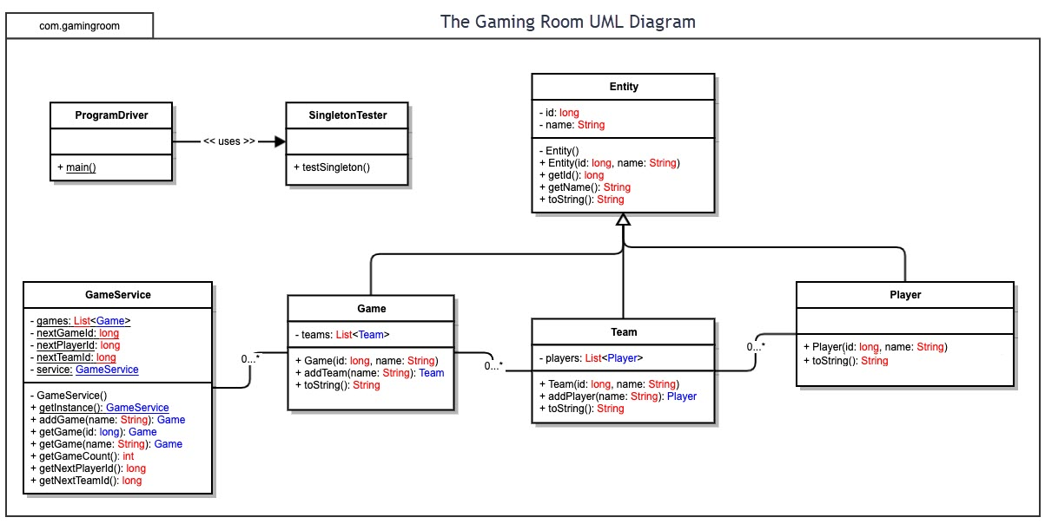

## Evaluation

Using your experience to evaluate the characteristics, advantages, and weaknesses of each operating platform (Linux, Mac, and Windows) as well as mobile devices, consider the requirements outlined below and articulate your findings for each. As you complete the table, keep in mind your client’s requirements and look at the situation holistically, as it all has to work together.

In each cell, remove the bracketed prompt and write your own paragraph response covering the indicated information.

| **Development Requirements** | **Mac** | **Linux** | **Windows** | **Mobile Devices** |
| --- | --- | --- | --- | --- |
| **Server Side** | Mac is like linux in that they both have flexible terminal commands to configure the server, access or makes changes. Mac is a closed operating system where only mac can release updates. With mac web hosting, mac hardware is required to run the software which is more expensive generally making mac web hosting even more expensive than windows. Mac is the least likely to get hacked although this is debatable since most hacking occurs from a server software issue. Mac is the most reliable server since the software and hardware rarely have errors leading to a crash. Mac is potentially the best web hosting option however is expensive. Mac hosting runs apache servers. | Is cheaper than a mac but has the ability of having flexible terminal commands to configure the server, access or make changes. Linux is free software where anyone can make changes or updates. Resources required to run linux web hosting is much less than windows or mac since a cheaper dell can be used. Since it’s an open source system it hardly crashes and your web host can use its own security matters making it the second most secure after mac. Linux like mac also runs on apache servers. | Has more software produced than the other operating systems which is important for hosting a java web server since there are several different ways to do this using various software based on your needs. One way is by using the wamp server package and tomcat for windows. Higher end hardware is required with windows servers since the server will crash if not enough CPU or RAM is present. Requires frequent updates which will sometimes require the server to be down. Only windows servers can run certain applications that use ASP, .NET, Microsoft Access or MSSQL databases. | Have limited memory and cache compared to computers. May have to use java for an android and swift for mac since they are native to that device. s |
| **Client Side** | Cost can be more expensive than windows. Updates from Mac can cost the client more money since mac is a closed operating system where only mac can release updates. Requires higher end software than linux which adds to the cost. Mac hosting is even more expensive than windows. Requires moderate expertise to use and is generally harder to learn to use than a windows computer. Mac web hosting is the most secure due to the limited software, complex code and proprietary Apple software making it harder for hackers to get into servers. Internet explorer is a browser that does not directly work on a mac so the web based application must work on safari as well which is macs default browser which comes with a mac. | Maximum expertise required for this system. Cost the least since Linux is a free software where anyone can alter, change or update. Most time is required for this system. Requires the least amount of maintenance. | Is the easiest to use with minimum expertise and time required. Cost is generally cheaper than a mac. Since windows is a closed operating system your web host must pay every time a new software version is released making it a more expensive option. Requires higher end hardware than mac adding to the cost. The server may sometimes be down due do an update. An older version of safari can be downloaded for windows however apple no longer makes safari for windows so the latest versions are not available. | Requires minimum expertise to use and time since it can be used anywhere. Its more difficult and timely to develop so may cost more to develop. Cheapest option for the client. |
| **Development Tools** | You can use any language some common ones include javascript, HTML, C, C++, python, php and ruby on rails. Tools include eclipse, github, pycharm and visual studios. | You can use any language some common ones include javascript, HTML, C, C++, python, php and ruby on rails. Tools include eclipse, github, pycharm and visual studios. | You can use any language some common ones include javascript, HTML, C, C++, python, php and ruby on rails. Tools include eclipse, github, pycharm and visual studios. | Java is commonly used for a mobile app and swift for iOS however you can use any language. Some common ones include javascript, HTML, C, C++, python, php and ruby on rails. Tools include eclipse, github, pycharm and visual studios. |

## Recommendations

Analyze the characteristics of and techniques specific to various systems architectures and make a recommendation to The Gaming Room. Specifically, address the following:

1. **Operating Platform**:

I recommend that windows is used as an operating platform this is since most people use windows computers and this will allow the company to expand the customer base for Draw it or lose it the most.

1. **Operating Systems Architectures**: Windows is produced and sold by Microsoft and has a layered design with user mode and kernel mode. Microsoft currently makes a 64 bit version of windows and previously made a 32 bit kind. It has a modular structure made up of several simple modules. The modular structure contains a hardware abstraction, kernel/microkernel, executive services, environment subsystem and integral system. A distributed system architecture could be used for this project to connect all components together.
2. **Storage Management**: A large amount of storage is required to hold all the images in the Draw it or Lose It game. The smallest amount of data for each picture should be used. The game is stored on the hard drive. The game is stored here in modules.

1. **Memory Management**: Memory is where the code currently executing is stored. The gaming application should be able to hold cache memory so it can be faster. The cache memory holds the data of the code which you often use. To manage memory, you should allocate it carefully and efficiently. Depending on the code used there are different methods for this. In python, you can use slots for objects, do not use interned strings, and use format instead of +. In C++ you can manage memory by reusing memory, using macros instead of small functions use int, float instead of char and try to avoid global variables.
2. **Distributed Systems and Networks**:

Distributed networking is the network system over which computer programming, software and its data are spread out across more than one computer but communicate messages through their nodes and depend on each other. Most products and applications run on distributed systems. In a distributed system if there is an outage where one system fails the availability of the service will not be affected. For Draw it or Lose it to communicate between different platforms a distributed database system should be used. In this method, a database located over multiple servers and physical locations can be used. Most applications use a distributed database system which can be homogenous or heterogeneous. I would use a homogenous distribution database since each system would have the same database management system and data model. Performance could be increased by adding new nodes and locations to store more images. The network could be connected with an IP address. Databases, objects and files could be connected. A company that could be used to connect and stream across disturbed system is called Confluent which offers a complete distributed platform.

1. **Security**:

In data security we must protect files, databases and accounts on a network. The core elements of data security are confidentiality, integrity and availability. I would implement continuous monitoring and real time alerting. If there was unusual file activity or a suspicious account or odd computer behavior an alert could be sent out so the company can monitor security. In order to protect data after three login attempts that are failed the account will be locked and the login must be reset by email. That would prevent a bot from being able to keep guessing passwords repeatedly till they get a correct one. To monitor for security beaches a data auditing solution should be in place to report access control changes to data, when the data was access by who and the file path. Good data auditing solutions will enable IT administrators to have the visibility needed to prevent unauthorized changes and potential breaches. Data real-time alerts will enable the company to find out about a data breach quickly instead of in several months through the customers. Real-time data monitoring will discover security breaches more quickly leaving to accidental destruction, loss, alteration, unauthorized disclosure of or access to personal data. Data risk assessments should also be used to identify which data is sensitive and to fix security risks. I would also use data minimization where I only ask for basic information to make an account since personal data can be a liability. I would also quarantine sensitive files to a secure location. SSL (Secure Sockets Layer) could be used to keep the internet connect secure and safeguarding any sensitive data sent between two systems. SSL uses encryption algorithms to scramble data in transit preventing hackers from reading it.